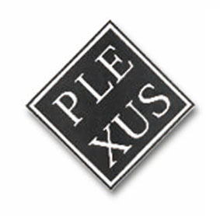
PLEXUS INTERNATIONAL FORUM
VIA GIOVANNI DA CASTELBOLOGNESE 89
00153 ROME
ITALY

School of International and Public Affairs
Executive MPA-Office of Admissions
420 West 118th Street,
New York, NY 10027-9720

Rome, 26 June 2003

Re: Appraisal letter for Mr. Jose Rodriguez

TO WHOM IT MAY CONCERN:

I am writing in support of the admission request made by Mr. Jose Rodriguez to your School.
Mr. Rodriguez is member of Plexus International, a network of artists and scientists from all over the world which is operating since 1982. I know Mr. Rodriguez since 1987 when he was the cultural program director at the Cultural Community Civic Center CUANDO (Culturas Unidas Aspireran Nuestro Destino Original), at Second Avenue in New York.
At that time, at CUANDO Center I was organizing, as coordinator of Plexus International, a multicultural arts exchange program involving artists from the communities of New York, Rome and Sardinia in Italy, Dakar in Senegal, and Amsterdam in Holland.
In 1989, Mr. Rodriguez played a seminal role in the establishment of the 1992 Cristopher Columbus Consortium among several departments of New York University, Ohio State University, Carnegie Mellon University, University of Cagliari, in Sardinia-Italy, and community cultural organizations in order to commemorate the 500th Anniversary of Columbus landing in the Americas with a cultural navigation program, called Navigating Global Cultures.
In 1992 and in 1998, I invited Mr. Rodriguez to participate in Sardinia-Italy to the First and to the Third International Symposium on the Well Being in the XXI Century which I organized for the University of Cagliari, and Mr. Rodriguez has made an outstanding contribution to both Symposia.
In 2003, in February, I invited him to come in Rome to develop a cultural program to be presented at the 2004 Culture Lab Festival at Yellow Rock in Australia and at the 2004 Biennal of Contemporary African Art oF Dakar by Plexus International focused on the role of the artist in the first person in order to survive the cultural heritage in the Community, locally and internationally, within the current globalization process.
Mr. Rodriguez has played a major role in the development of Plexus International as an international community based art initiative by providing the conceptual framework for the cultural identification of the artist role within a multicultural community context
The international study that he intends to pursue at your School I am sure that promises to be a real contribution to the field.
I hope that his request will receive support from your School, Mr. Rodriguez, for my personal long knowledge of him, is a person of vast education and cultural competence and of great potential.
Sincerely Yours

Dr. Sandro Dernini, Ph.D.,
Chairman

