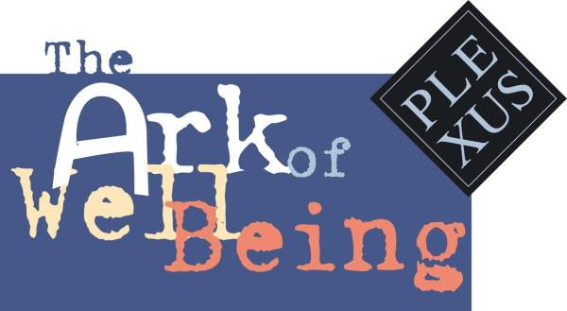
THE DOOR OF NO RETURN CALL
FOR THE SAFEGUARD
OF THE NATURAL AND CULTURAL HERITAGE OF HUMANKIND
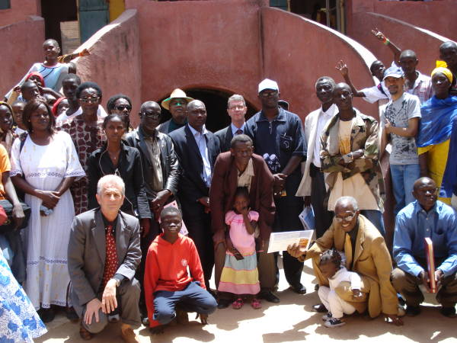
12 May 2008
House of the Slaves
Gorèe, Dakar, Senegal

As a group of concerned individuals, gathered the 12 of may 2008 in Gorèe, Dakar, Senegal, for the “Erosions and Renaissance Show Act VIII,” focused on the sea erosion of the Door of No Return of the House of the Slaves, as a symbol of all growing “erosions” in the world, we issued a Call for the safeguard of our cultural and natural heritage. This call in particular is addressed to UNESCO, FAO, Biodiversity International, the World Bank and the Office of the High Commissioner for Human Rights.

On the occasion of the 60 Anniversary of the Universal Declaration of Human Rights, we underline also the urgent need for the development of a specific plan for safeguarding the House of the Slaves of Gorèe.

12 May 2008, Island of Gorèe, Dakar, Senegal

