
EROSIONS and RENAISSANCE
ACT III
EATING ART
29 Sept. -1 Oct. 2005
Aula Magna Atrium
University “La Sapienza of Rome

1 October
National Accademy of Dance
Rome

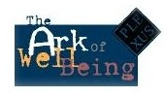

"EROSIONS and RENAISSANCE" is a travelling community-based art event, made by several acts in different geographical areas of the world, to warn on increased “erosions” in the living planet.
From 29 September to October 1, 2005, its 3rd Act will be at the University of Rome “La Sapienza, within “Eating Art” an esposition/ choreo event realized, in collaboration with the National Academy of Dance, for the international event “2005 Year of the Mediterranean”, on the occasion of the Italian Celebrations of the World Food Day 2005 “Agriculture and Intercultural Dialogue”.

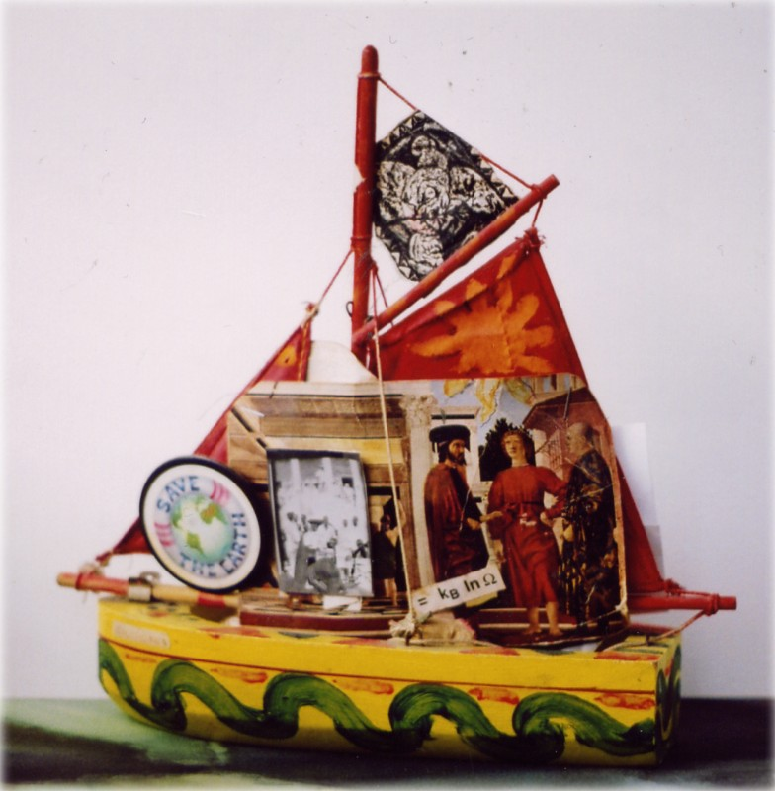
Colombina Boat by Silvio Betti, Rome 1991

It will travel on board the WellBeing Ark, a multimedia online installation, presented in 1996 in Rome at “Eating Art/Get the Best from Your Food/Food for All”, a special event held at the Palazzo delle Esposizioni, on the occasion of the FAO World Food Summit.
3rd Act opened on 28 May in Lecce at the Academy of Fine Arts, in collaboration with Raggio Verde Edition, to alert on the increasing erosion of the world cultural heritage and related humankind wellbeing. In particular, 3rd Act to warn on the desertification in the Mediterranean and of the erosion of the diversity of Mediterranean food cultures.
1st Act was staged at the Medina of Dakar, in June 2004, at 2° Le Triangle de l’Art Festival”, within the DakArtOff of the Biennale of Contemporary African Art, to draw attention to the dramatic sea erosion of the Door of No Return of the House of the Slaves in Goree, an UNESCO World Heritage site, as symbol of the erosion of humankind.
2nd Act was staged in Ballarat, Australia, in December 2004, by Culture Lab International, for the Eureka Rising Festival 100 Years. It raised attention on the emu eggs’ erosion in the Maroota Plateau, a sacred Aboriginal ground, in the Blue Mountains, an other UNESCO World Heritage site.
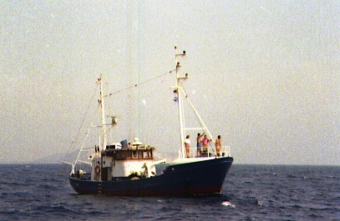
The Voyage of the Elisabeth, Sardinia

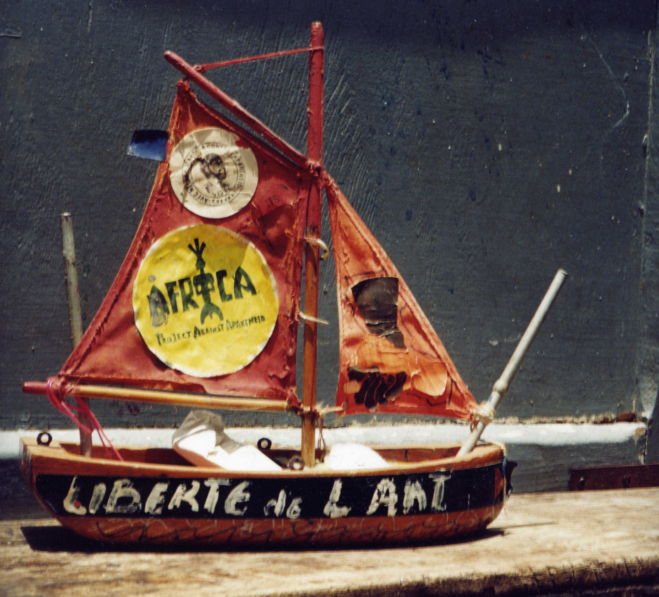
Libertè de l’Art by Gaetano Brundu, Cagliari 1988

4th Act, dedicated to the 100 anniversary of Albert Einstein’s relativism and Don Cherry’s world music heritage, will be in New York on 10 December 2005, Human Rights Day, to alert on the erosion of all human rights, in particular of Food for All.
Final 5th Act will be staged in May 2006, at the 3rd Triangle of Art Festival, in the Medina of Dakar, on the occasion of the Biennale of Contemporary African Art.
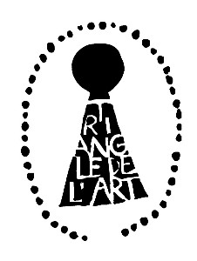Triangle de l’Art Festival 2006
All printed digital artworks, hundreds from Act 1 to Act 5, united together as a very long colourful collective roll meter will accompany the measurement of the current sea erosion of the Door of No Return of Goree from 2002 to 2006.
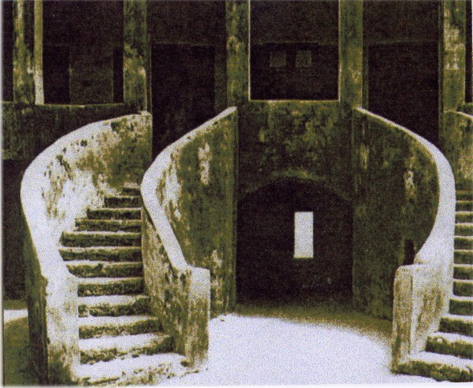
The House of Slaves of Goree

It will launch again a warn on the increasing sea erosion as well as of the desertification in Africa and in the Mediterranean.

Plexus International is a network of artists and scientists. Since its beginnings in 1982, in New York City, it has performed numerous cross-cultural experimental art events “art co-operas”, involving hundreds of artists and scientists around the world, linking the notion of “culture” as a community sustainable development resource - to the achievement of the "well-being" - as a human right for all people.

 | A co-production of Plexus International Forum Onlus
Via G. da Castelbolognese 89, 00153 Roma
Tel./Fax 0039.06-99700208
Email: s.derniniiscali.it
Website: www.plexusforum.net

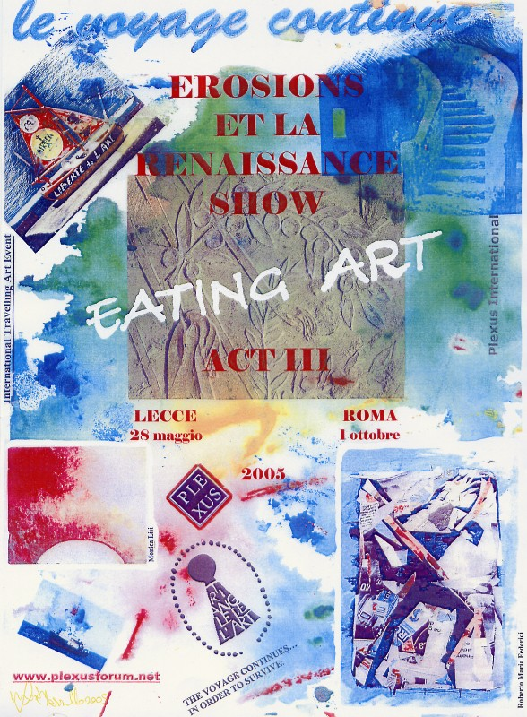
Artwork by Luisa Mazzullo, Rome 2005

Submission of ArtWorks for Act 3: Emailing your artwork to: s.dernini@tiscali.it Image Format: Email your image with 300x300 dpi, in jpg format, for the Plexus Virtual Gallery www.plexusforum.net

We print all digital works in large laser colour photocopies, to be exhibited together with all hundred images from previous acts in Rome, on October 1, 2005, at the National Academy of Dance.
More Info: www.plexusforum.net
Sandro Dernini s.dernini@tiscali.it

