YOU ARE INVITED ON BOARD
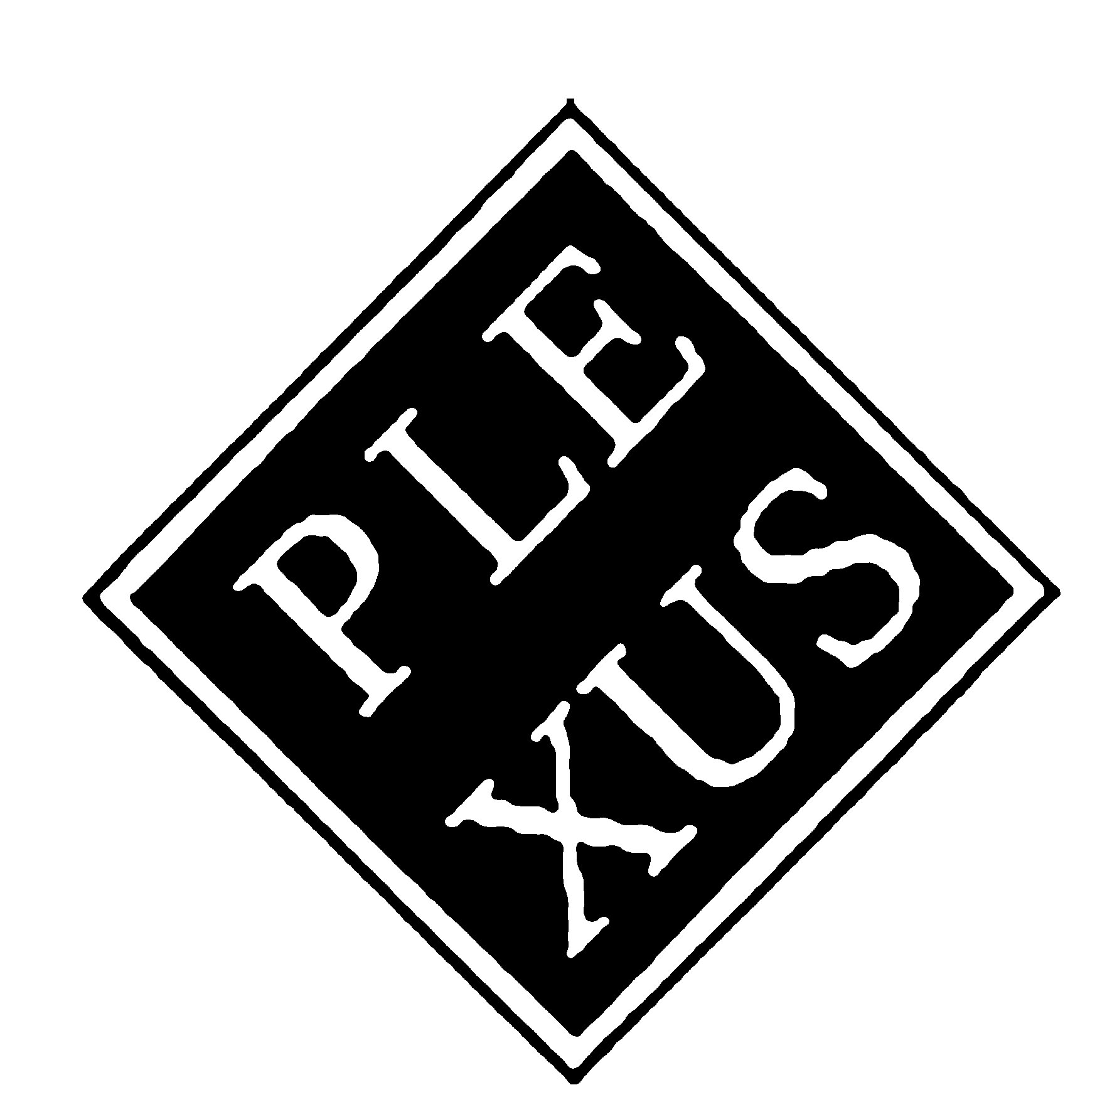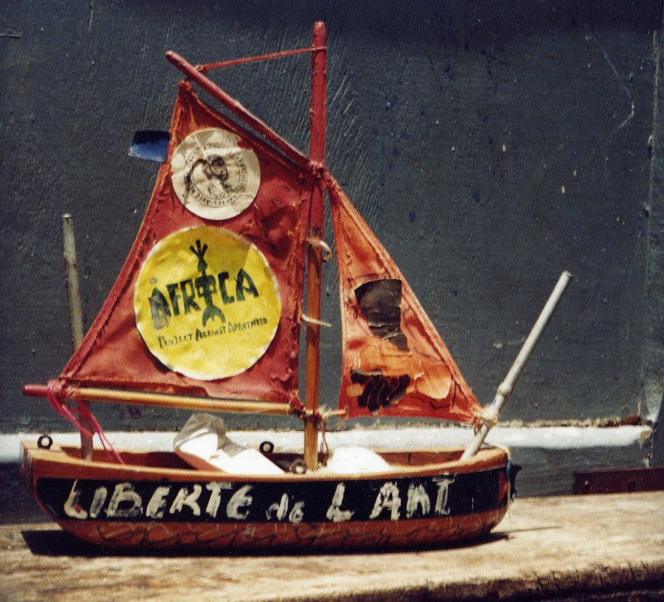
International Travelling Art Event

FROM AUSTRALIA TO
ITALY - MEDITERRANEAN
EROSIONS and RENAISSANCE
ACT III
EATING ART
28 May 2005
Academy of Fine Arts
Lecce (Puglia) Italy
29 September 2005
Aula Magna Atrium
University “La Sapienza of Rome
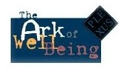
THE VOYAGE CONTINUES…
IN ORDER TO SURVIVE
Act 3 departs on 28 May, from the Academy of Fine Arts in Lecce (South of Italy). It will land on 29 September 2005, at the University of Rome “La Sapienza in Rome, on the occasion of the event “Eating Art”, presented by the Institute of Food Sciences, within the 3rd EuroMed Forum on Food Cultures on the occasion of the 2005 Year of the Mediterranean and the Italian Celebrations of the World Food Day 2005 “Agriculture and Intercultural Dialogue”

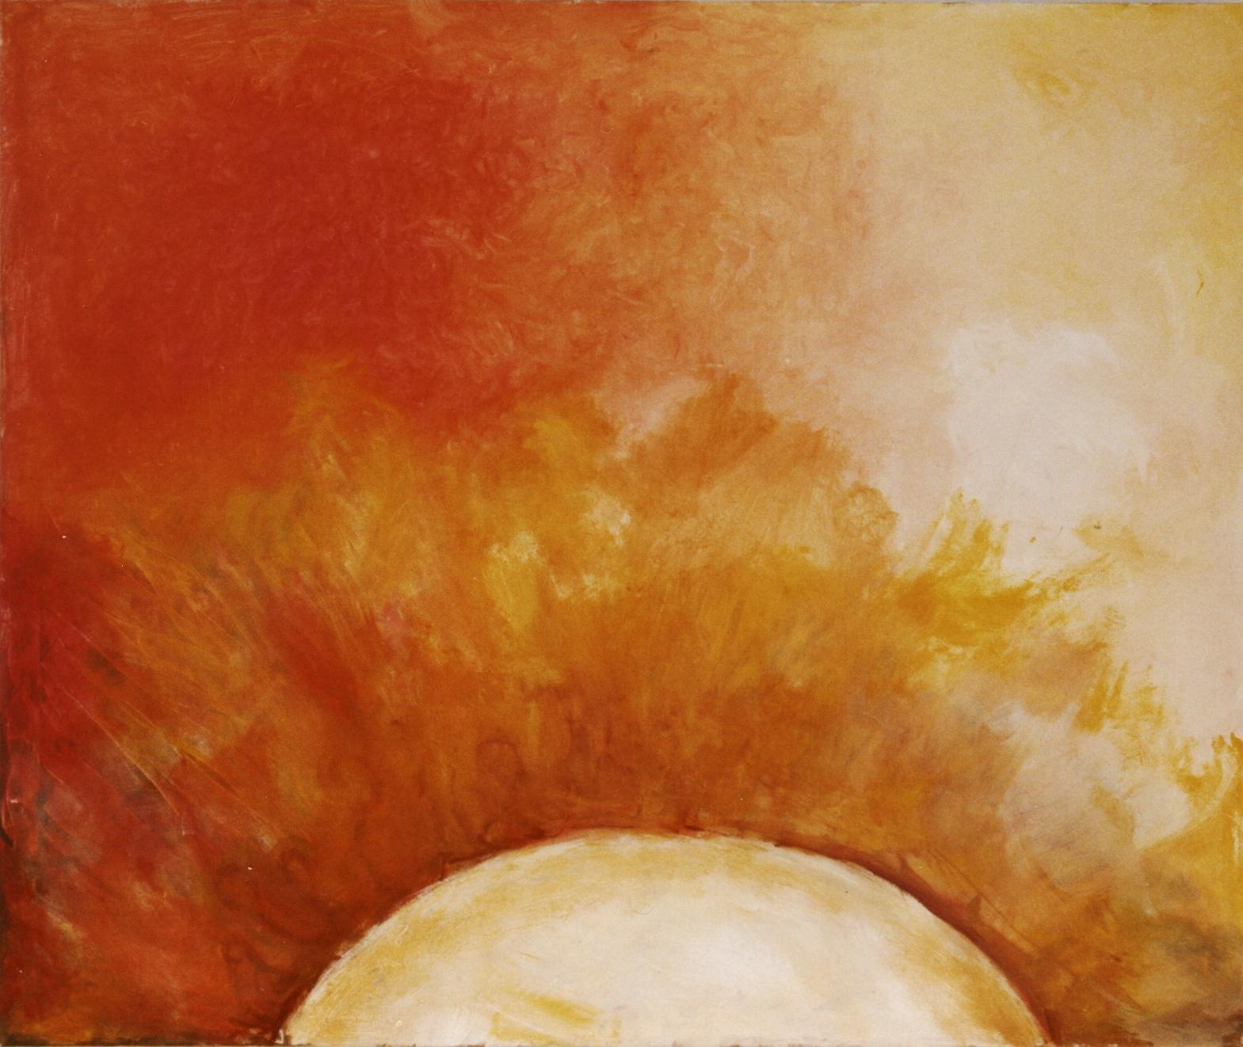
Artwork by Monica Lisi, Lecce (Italy) 2004

"EROSIONS and RENAISSANCE" is a travelling community-based art event to warn on increased “erosions” in the living planet. 1st Act was staged at the Medina of Dakar, in June 2004, at 2° Le Triangle de l’Art Festival”, within the DakArtOff of the Biennale of Contemporary African Art, to draw attention to the dramatic sea erosion of the Door of No Return of the House of the Slaves in Goree, an UNESCO World Heritage site, as symbol of the erosion of humankind.
2nd Act, staged in Ballarat, Australia, in December 2004, by Culture Lab International, for the Eureka Rising Festival, raised attention on the emu eggs’ erosion in the Maroota Plateau, a sacred Aboriginal ground, in the Blue Mountains, an other UNESCO World Heritage site.
3rd Act opens on 28 May in Lecce from the Academy of Fine Arts, in collaboration with Raggio Verde Edition, to continue alerting on the erosion of the world cultural heritage and related humankind wellbeing. In particular, 3rd Act will warn on the desertification in the Mediterranean, on the erosion of its landscapes and of the diversity of Mediterranean food cultures.
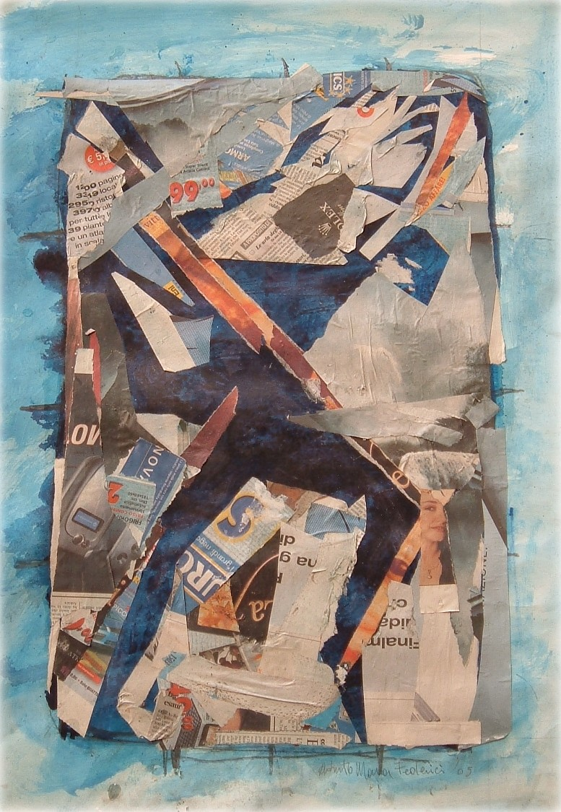
Artwork by Roberto Maria Federici, Rome 2005

It will land in Rome on September 29 into the WellBeing Ark, a multimedia online installation, at the atrium of the Aula Magna of the University of Rome within the exhibition/choreo event “Eating Art”, in collaboration with ScenaMobile and Nuove Forme Sonore.
At the University of Rome, it will be stressed how the erosion of the Mediterranean diet, and related life style, quality of life, health and well being is increasing in the entire Mediterranean. The WellBeing Ark was presented in 1996 in Rome at “Eating Art/Get the Best from Your Food/Food for All”, a special event held at the Palazzo delle Esposizioni, on the occasion of the FAO World Food Summit.
4th Act, dedicated to the 100 anniversary of Albert Einstein’s relativism and Don Cherry’s world music heritage, will be in New York on 10 December 2005, Human Rights Day, to alert on the erosion of all human rights, in particular of Food for All.
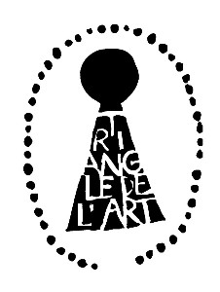 | 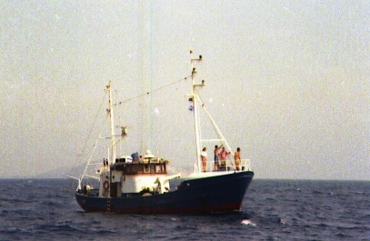
Final 5th Act, with an international cast dedicated to All Street Children in the World, will be in May 2006, at the 3rd Triangle of Art Festival, in the Medina of Dakar, on the occasion of the Biennale of Contemporary African Art. It will stress the erosion of the human rights of Food, Education and Health for All as well as will launch again a warn on the increasing sea erosion as well as of the desertification in Africa and in the Mediterranean. All printed digital artworks, hundreds from Act 1 to Act 5, united together as a very long colourful collective roll meter will measure the current sea erosion of the Door of No Return of Goree from 2002 to 2006.
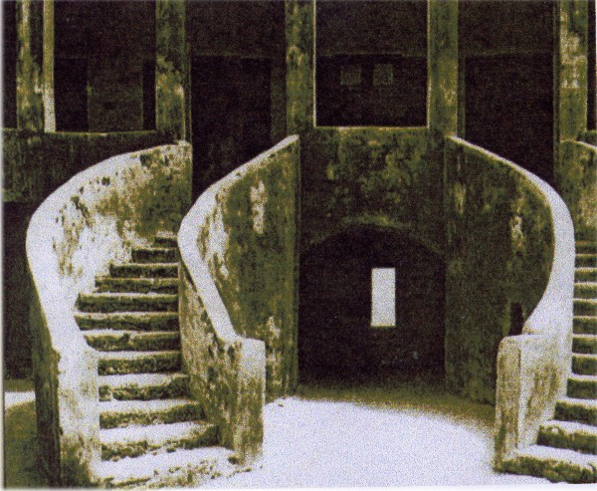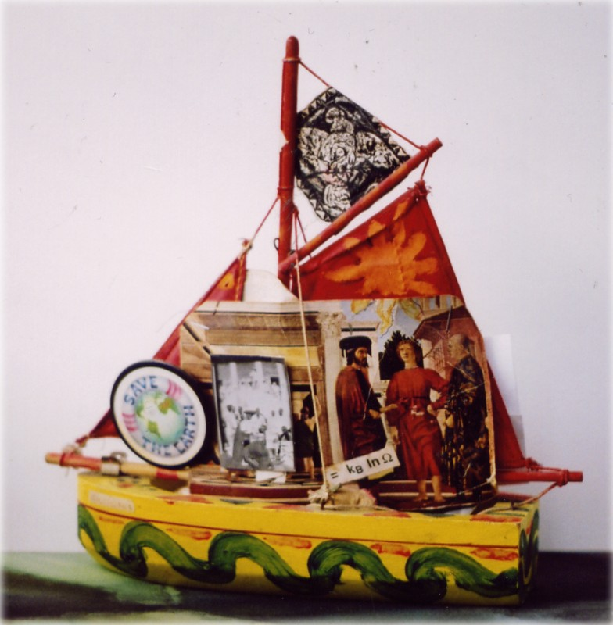
All erosion data, collected around the world, will be presented through a press conference to represent to FAO, and for the first time, to UNESCO,WHO and European Commission, the Plexus historical proposal of a World Art Bank, as an online virtual project, symbolically placed at the Door of No Return of Goree, in support to the development of street children community-based food and nutrition education art projects, starting from the Medina-Dakar community. Plexus International is a network of artists and scientists. Since its beginnings in 1982, in New York City, it has performed numerous cross-cultural experimental art events “art co-operas”, involving hundreds of artists and scientists around the world, linking the notion of “culture” as a community sustainable development resource - to the achievement of the "well-being" - as a human right for all people.

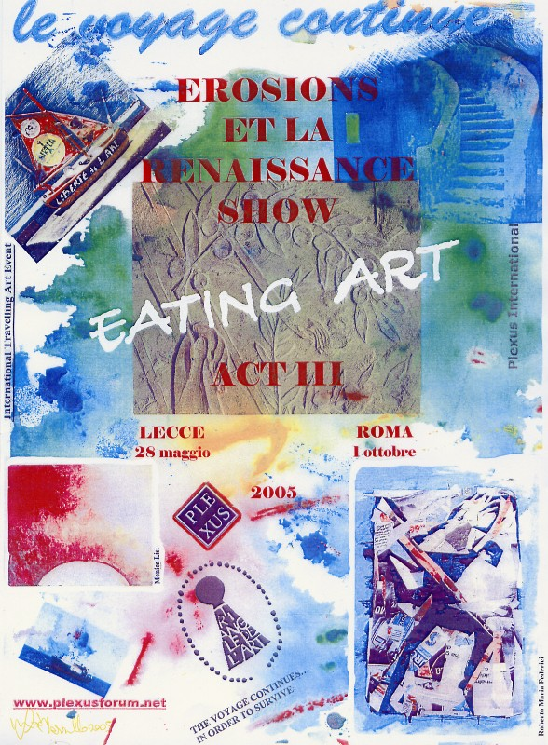
Artwork by Luisa Mazzullo, Rome 2005
Submission of ArtWorks: Emailing your artwork to: s.dernini@tiscali.it Image Format: Email your image with 300x300 dpi, in jpg format, for the Plexus Virtual Gallery www.plexusforum.net We print all digital works in large laser colour photocopies, to be shown with images from previous acts in Lecce and Rome
INFO www.plexusforum.net
Lecce: Monica Lisi monalisa.71@libero.
Rome: Sandro Dernini s.dernini@tiscali.it
Dakar Assane MBaye cheikhassane@caramail.com
New York: Joanee Freedom JoaneeF@aol.com
Australia: Culture Lab Willem Brugman willem@culturelab.org.au
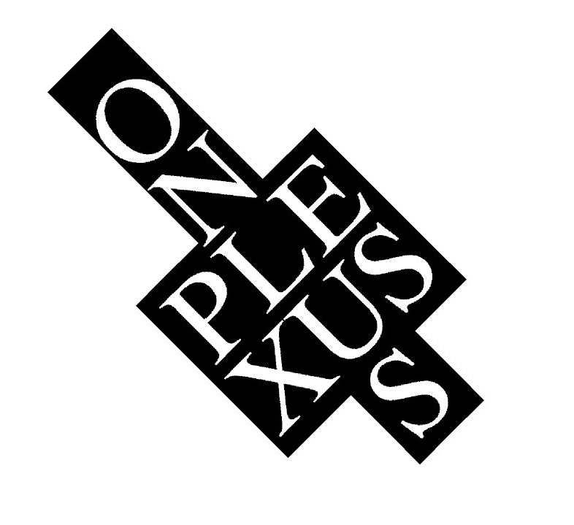 | A co-production of Plexus International Forum Onlus, Cagliari (Rome

